**Week 8 Solutions**

**Mandatory Hands-on**

**Exercise 1**

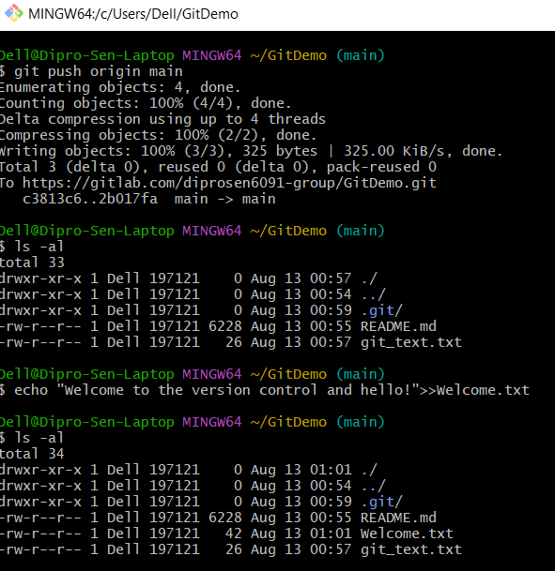

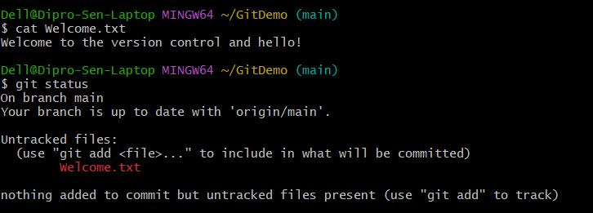

**Exercise 2**

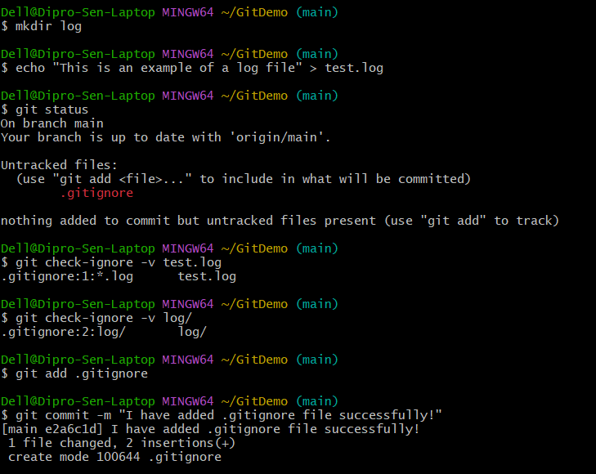

**Exercise 3**

**Branching**

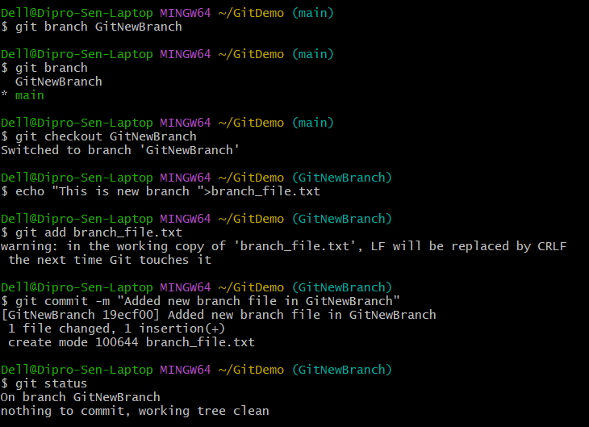

**Merging**

**Exercise 4**

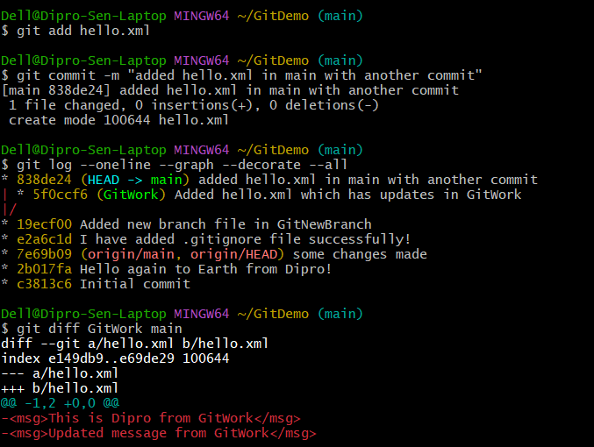

**Exercise 5**



